
DEPARTMENT OF AIDS
UNIT – 1 MINI PROJECT REPORT
on
Enterprise Student Record and Academic Management Platform

Design Thinking and Product Planning

Submitted By :
Madhuri Shivaji Jape [2126UDSF2560]

Under the Guidance of :
Prof. Karan Gaikwad

Subject: DevOps and Cloud Foundation (IBM)
Department: AIDS-SY
Academic Year: 2026–2027

CERTIFICATE
This is to certify that Madhuri Jape has completed the Unit–1 Mini Project titled “EduBridge – Academic Operations & Student Success Platform” as part of the DevOps and Cloud (IBM) course curriculum.
The report demonstrates an independent application of the prescribed product-planning activities. It covers business understanding, stakeholder analysis, user personas, Design Thinking, IBM Design Thinking, requirements engineering, product vision, MVP planning, roadmap development, initial architecture, project charter and repository planning.
The work is prepared for academic evaluation and represents the planning stage of a software product before detailed Agile implementation.

DECLARATION
I, Madhuri Shivaji Jape, hereby declare that this Unit–1 Mini Project Report titled “EduBridge – Academic Operations & Student Success Platform” has been prepared for academic submission in the DevOps and Cloud Foundation (IBM) course.
The report has been developed according to the activities and deliverables specified in the Unit–1 Mini Project Guide. The reference material was used to understand the required structure, concepts, and learning outcomes, while the project concept, examples, requirements, personas, analysis, and planning decisions have been developed specifically for this submission.
This report represents a product-discovery and planning exercise and does not claim that the proposed EduBridge platform has already been fully implemented, deployed, or tested in a production college environment. The work has been prepared for academic and educational purposes.

ACKNOWLEDGEMENT
I sincerely express my gratitude to my subject faculty Prof. Karan Gaikwad for providing valuable guidance and support throughout the preparation of this Unit–1 Mini Project Report. His guidance helped me understand the importance of software product engineering, Design Thinking, IBM Design Thinking, requirements analysis, and structured product planning.
I am also thankful to the Department of AIDS and the institution for providing the necessary academic environment and resources to undertake this project. I acknowledge the Unit–1 project guide and reference materials provided for the course, which helped me understand the expected activities, deliverables, terminology, and documentation structure.
I am grateful for the opportunity to explore the EduBridge concept from a user, business, and product perspective before moving toward detailed software development. The analysis, requirements, personas, and planning presented in this report have been developed as part of my academic learning and project work.

ABSTRACT
EduBridge – Academic Operations & Student Success Platform is a proposed digital platform designed to streamline academic operations and improve visibility into student-related activities. In many educational institutions, academic information and routine processes are distributed across spreadsheets, notices, messaging applications, and separate records. This can result in repeated data entry, delayed communication, fragmented information, and difficulty in tracking pending academic activities.
EduBridge proposes a centralized academic workspace connecting students, faculty members, department coordinators, and examination staff through role-specific interfaces. The platform is envisioned to support activities such as course registration, attendance monitoring, assessment schedules, internal marks, academic requests, notifications, and institutional reporting.
The proposed system also includes workflow-oriented features that can help identify pending tasks and provide timely reminders or notifications. This can reduce dependence on manual follow-ups and provide users with better visibility of academic activities.
This Unit–1 mini project focuses primarily on product discovery, Design Thinking, and product planning rather than full implementation. The report applies the five stages of Design Thinking—Empathize, Define, Ideate, Prototype, and Test—along with the three principles of IBM Design Thinking and the Observe → Reflect → Make loop.
The report further presents stakeholder analysis, user personas, business and system requirements, functional and non-functional requirements, product vision, success measures, MVP scope, product roadmap, initial system architecture, project milestones, repository structure, and product discovery documentation. These activities establish a foundation for future Agile development and implementation of the proposed EduBridge platform.
Keywords: Academic Operations, Student Success, Student Records, Workflow Automation, Design Thinking, IBM Design Thinking, DevOps, Requirements Engineering, MVP, Product Roadmap.

TABLE OF CONTENTS
Sr. No. | Chapter / Section | Page No.
1 | Introduction and Project Objective | 1
2 | Business Understanding | 2
3 | Business Problem and Requirements | 3
4 | Stakeholder Analysis | 4
5 | User Persona Development | 5
6 | Design Thinking | 6
7 | Design Thinking – Empathize | 7
8 | Design Thinking – Define | 8
9 | Design Thinking – Ideate | 9
10 | Design Thinking – Prototype | 10
11 | Design Thinking – Test | 11
12 | IBM Design Thinking Application | 12
13 | IBM Loop – Observe → Reflect → Make | 13
14 | Functional Requirements Specification | 14
15 | Non-Functional Requirements Specification | 15
16 | Product Vision and Success Measures | 16
17 | Minimum Viable Product (MVP) | 17
18 | Product Roadmap | 18
19 | Initial System Architecture | 18
20 | Project Charter and Milestones | 19
21 | Repository Initialization and Folder Structure | 20
22 | Product Discovery Documentation | 20
23 | Conclusion and Future Direction | 21

1. INTRODUCTION AND PROJECT OBJECTIVE
Software product engineering begins with understanding the environment in which a system will operate. For an academic institution, the challenge is not simply to store student information. The product must support recurring academic activities, clearly separate responsibilities and make important information available when decisions are required.

1.1 Project Objective
- Study the academic-management workflow from the viewpoint of multiple users.
- Identify friction in registration, attendance, assessment, academic requests and reporting.
- Use Design Thinking to move from observed needs to a testable product concept.
- Apply IBM Design Thinking principles to keep the product focused on measurable user outcomes.
- Define functional and non-functional requirements before implementation.
- Create an MVP that is small enough for an initial Agile release.
- Prepare an architecture and repository structure suitable for later DevOps activities.

1.2 Project Scope
The scope covers product discovery and planning. It includes academic workflow analysis, personas, requirements, prototype planning, MVP definition, roadmap and architecture. Coding, cloud provisioning, CI/CD execution and production monitoring are intentionally treated as later-stage activities.

1.3 Product Concept
EduBridge combines academic records with workflow visibility. A student can see relevant academic information and pending actions; faculty can complete academic tasks; coordinators can monitor exceptions; and examination staff can manage assessment-related records. The concept emphasizes clarity and timely action rather than adding a large number of features.

2. BUSINESS UNDERSTANDING
The Unit–1 brief requires the student to understand admissions, course registration, attendance, examinations and result management before defining the software. EduBridge therefore treats these operations as connected stages in one academic journey.

Academic Activity | Typical Input | Operational Difficulty | EduBridge Opportunity
Student onboarding | Student and program details | Repeated entry across forms | Unified student profile
Course registration | Semester subjects and choices | Approval status is hard to track | Registration workflow with status
Attendance | Class-wise attendance | Students discover shortages late | Attendance summary and threshold notice
Assessment | Schedules, marks, components | Information scattered across notices | Assessment calendar and marks view
Results | Validated semester outcomes | Report preparation can be repetitive | Structured result publication
Academic requests | Bonafide, correction, approvals | Manual follow-up and queues | Request tracking with ownership
Reporting | Department-level summaries | Data assembled from multiple files | Role-based reporting workspace

2.1 Business Gaps Identified

- Information may exist but is not always visible to the person who must act on it.
- Different academic activities can maintain separate versions of similar student data.
- Students may depend on notices or manual follow-up to understand pending actions.
- Faculty and coordinators may spend time preparing status summaries instead of resolving exceptions.
- Administrative reporting can become repetitive when data is distributed across files.

2.2 Proposed Business Response

EduBridge proposes a role-based academic workspace with a common student record, task status, academic calendar, controlled updates and report views. The platform is planned to reduce unnecessary handoffs while keeping responsibilities explicit.

3. BUSINESS PROBLEM AND REQUIREMENTS

3.1 Core Problem Statement

Higher-education academic activities are often handled through disconnected workflows. Students need to know what is completed and what requires action, faculty need efficient ways to update academic information, and administrators need reliable summaries. When these needs are supported by separate records and manual communication, delays and duplicated effort can occur.

3.2 Business Requirements

ID | Business Requirement | Expected Value
BR-01 | Maintain one authoritative student academic profile. | Less duplication and clearer records.
BR-02 | Track course registration from request to approval. | Students can see current status.
BR-03 | Provide attendance summaries and threshold notices. | Earlier awareness of attendance issues.
BR-04 | Maintain assessment schedules and marks. | More organized academic information.
BR-05 | Support controlled academic requests. | Clear ownership and traceability.
BR-06 | Provide role-specific dashboards. | Relevant information without clutter.
BR-07 | Generate structured academic reports. | Reduce repetitive compilation.
BR-08 | Maintain an audit trail for important changes. | Improved accountability.
BR-09 | Support future integration and scaling. | Allows later product growth.

3.3 Business Outcome
The intended outcome is a product plan that can move into Agile development with a clear understanding of users, workflows, priorities and acceptance expectations. The platform is not intended to replace every institutional system in its first release; it is intended to prove a coherent academic workflow experience.

4. STAKEHOLDER ANALYSIS
Stakeholder analysis identifies who contributes information, who uses the product, who approves actions and who maintains the technical environment.

Stakeholder | Interest | Main Responsibility | Expected Product Support
Students | High | Use academic services and monitor status | Simple personal dashboard and alerts
Faculty | High | Record attendance/marks and review requests | Fast entry and action queues
Department Coordinator | High | Monitor course and student-level issues | Department dashboard and exceptions
Examination Cell | High | Manage schedules and result processes | Controlled exam/result workspace
Academic Office | Medium-High | Validate institutional records | Search, reports and audit trail
IT Support | Medium | Maintain access, infrastructure and support | Administration, logs and diagnostics
Management | Medium | Review institutional trends | Summary reports and indicators

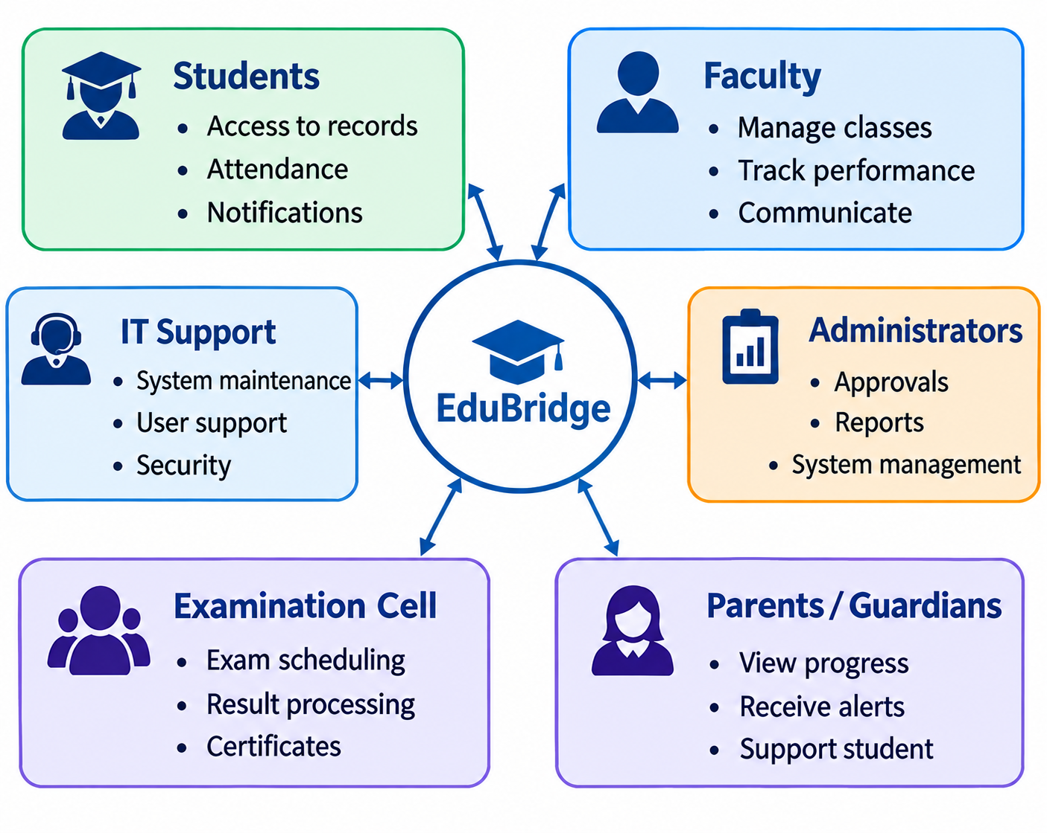

4.1 Responsibility Matrix

Activity | Student | Faculty | Coordinator | Exam Cell | IT
Course registration | R | C | A | - | I
Attendance | I | R | A | - | I
Assessment entry | I | R | C | A | I
Result publication | I | C | A | R | I
Access management | I | C | A | - | R
System maintenance | I | I | C | I | R

R = Responsible, A = Accountable, C = Consulted, I = Informed.

5. USER PERSONA DEVELOPMENT
Personas convert stakeholder categories into realistic user goals, behaviors and frustrations. They are used to prevent the product from being designed only around technical functions.

Persona | Goal | Challenges | Expected Experience
Neha – Student | Understand academic status and complete tasks on time. | Multiple notices, unclear pending actions. | One personal view of status and next steps.
Prof. Kulkarni – Faculty | Update academic data without repetitive work. | Time pressure and scattered lists. | Fast entry with clear pending items.
Mr. Deshmukh – Coordinator | Spot unresolved academic issues. | Department data is difficult to summarize. | Exception-focused dashboard.
Ms. Shah – Exam Officer | Process exam information accurately. | Multiple sheets and validation steps. | Controlled exam/result workflow.
Riya – IT Support | Keep access and services dependable. | User access issues and support requests. | Admin tools, logs and clear role controls.

5.1 Persona Insights

- Students need clarity more than additional complexity.
- Faculty workflows should minimize clicks during time-sensitive academic work.
- Coordinators need exception visibility instead of reading every record.
- Examination staff require controlled processes because result data is sensitive.
- IT support needs maintainability, role management and operational visibility.

5.2 Design Implication

The product should present information according to the user's task. A student should not see administrative controls; an examination officer should not have to navigate a student-style dashboard. This supports role-based access and task-oriented interface design.
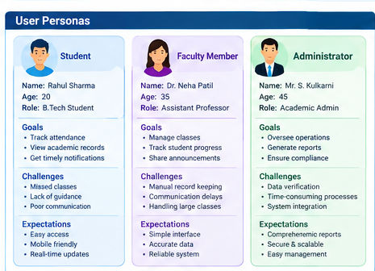

6. DESIGN THINKING
Design Thinking is a human-centered approach to problem solving that focuses on understanding users, identifying their real problems, generating ideas, creating solutions, and testing them with users.
For the Enterprise Student Record and Academic Management Platform, Design Thinking helps us understand the needs of students, teachers, administrative staff, and IT support staff before developing the actual software.

6.1 Stages of Design Thinking

Stage | Purpose | Activities
1. Empathize | Understand users and their problems | Observation, interviews, workflow study
2. Define | Clearly identify the main problem | Problem statements, user needs, pain points
3. Ideate | Generate possible solutions | Brainstorming, idea generation
4. Prototype | Create a basic version of the solution | Wireframes, screen designs, mock-ups
5. Test | Check the solution with users | User testing, feedback, improvements

6.2 Design Thinking Cycle

Empathize → Define → Ideate → Prototype → Test → Improve
It is not always a straight-line process. Feedback from testing can send the team back to Ideate, Define, or even Empathize.
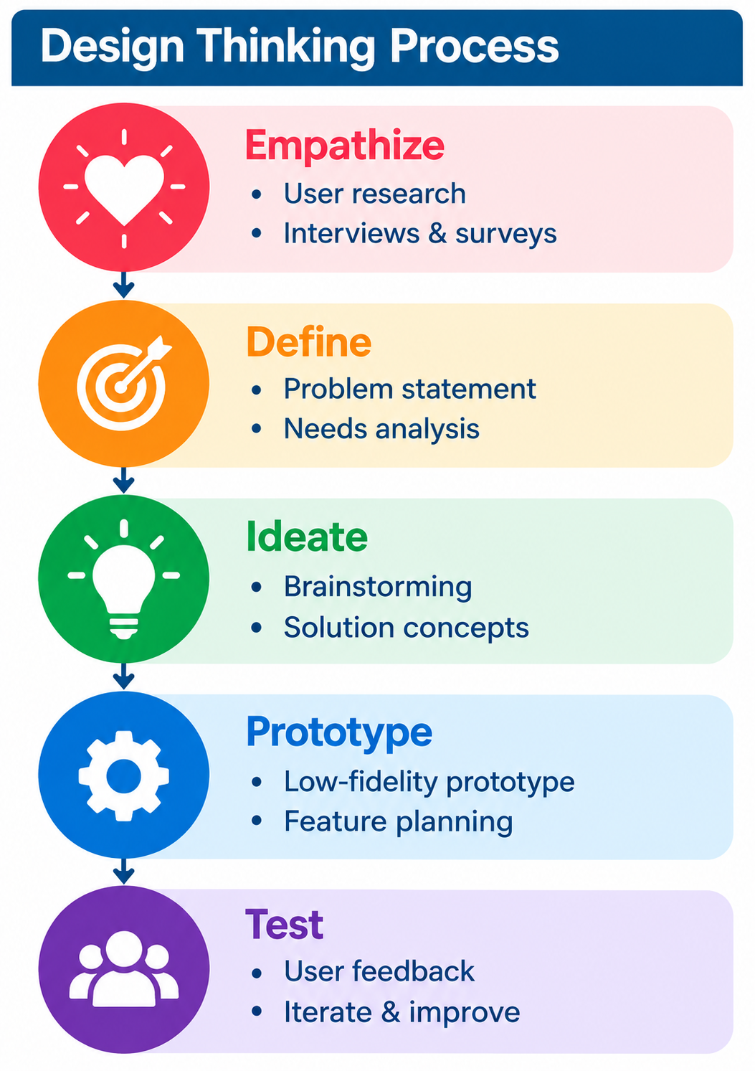

7. DESIGN THINKING – STAGE 1: EMPATHIZE
The Empathize stage focuses on understanding the people behind the workflow. For this academic project, the discovery plan considers observation, short interviews, workflow walkthroughs and review of existing forms or registers.

7.1 Discovery Questions

Area | Questions
Registration | Where does a student begin, and how does the student know registration is approved?
Attendance | When does a student first realize that attendance is becoming a concern?
Assessments | How are schedule changes communicated and confirmed?
Marks | Who enters marks, who verifies them and who can correct them?
Requests | How does a student know who currently owns a request?
Reporting | Which summaries are prepared repeatedly by staff?
Support | What problems require IT intervention most often?

7.2 Pain-Point Themes

- Status information is often distributed between people, messages and documents.
- Users may know that an action exists but not who is responsible for the next step.
- Academic information becomes more difficult to interpret when it is separated by process.
- Manual reporting can consume time that could otherwise be used for academic support.
- Different users need different levels of detail from the same underlying record.

7.3 Empathy Outcome

The discovery stage suggests that the product should make status, ownership and next actions visible. The goal is not merely digitization; it is to reduce uncertainty in everyday academic work.

8. DESIGN THINKING – STAGE 2: DEFINE

8.1 Defined Problem

Academic stakeholders need a shared but role-controlled workspace that shows the current status of registration, attendance, assessments, results and academic requests, because fragmented processes make it difficult to know what is complete, what is pending and who must act next.

8.2 User Need Statements

User | Need Statement
Student | I need to see my academic status and pending actions in one place so I can respond before deadlines.
Faculty | I need quick academic data-entry and clear pending work so routine administration does not interrupt teaching.
Coordinator | I need to identify exceptions and unresolved cases so I can intervene without manually checking every record.
Exam Officer | I need controlled workflows and validation so exam and result information remains accurate.
IT Support | I need clear roles, logs and maintainable components so operational issues can be diagnosed safely.

8.3 How Might We Questions

- How might we make academic status understandable without exposing unnecessary data?
- How might we reduce repeated entry while preserving accountability?
- How might we surface exceptions without creating notification overload?
- How might we make the product useful on both student and administrative screens?

8.4 Design Goal

Design an academic operations experience that makes the next required action visible, traceable and appropriate to the user's role.

9. DESIGN THINKING – STAGE 3: IDEATE
Ideation deliberately considers multiple solution directions before narrowing the MVP. Ideas are evaluated against user value, feasibility, risk and their contribution to the core workflow.

Idea | Purpose | MVP Decision | Reason
Personal academic dashboard | Show relevant status and tasks. | Include | Core student experience.
Registration workflow | Track requests and approvals. | Include | Directly addresses status uncertainty.
Attendance threshold notice | Surface potential attendance concern. | Include | Useful and relatively bounded.
Assessment calendar | Centralize upcoming academic events. | Include | Supports planning.
Academic request tracker | Show owner and status. | Include | Improves transparency.
Smart notification rules | Trigger selected reminders. | Limited | Avoid notification overload in first release.
Advanced analytics | Explore trends across cohorts. | Later | Requires stable data and metrics.
AI academic assistant | Answer student questions. | Later | Needs validation after core workflows.

9.1 Idea Prioritization Logic

Ideas that directly reduce uncertainty in the core academic workflow are prioritized for the MVP. Features that require large datasets, complex external integrations or advanced intelligence are intentionally deferred. This keeps the first product testable and prevents scope from expanding faster than learning.

9.2 Concept Summary
Student/Staff Login → Role Dashboard → Academic Workflow → Status Update → Action/Approval → Report or Alert
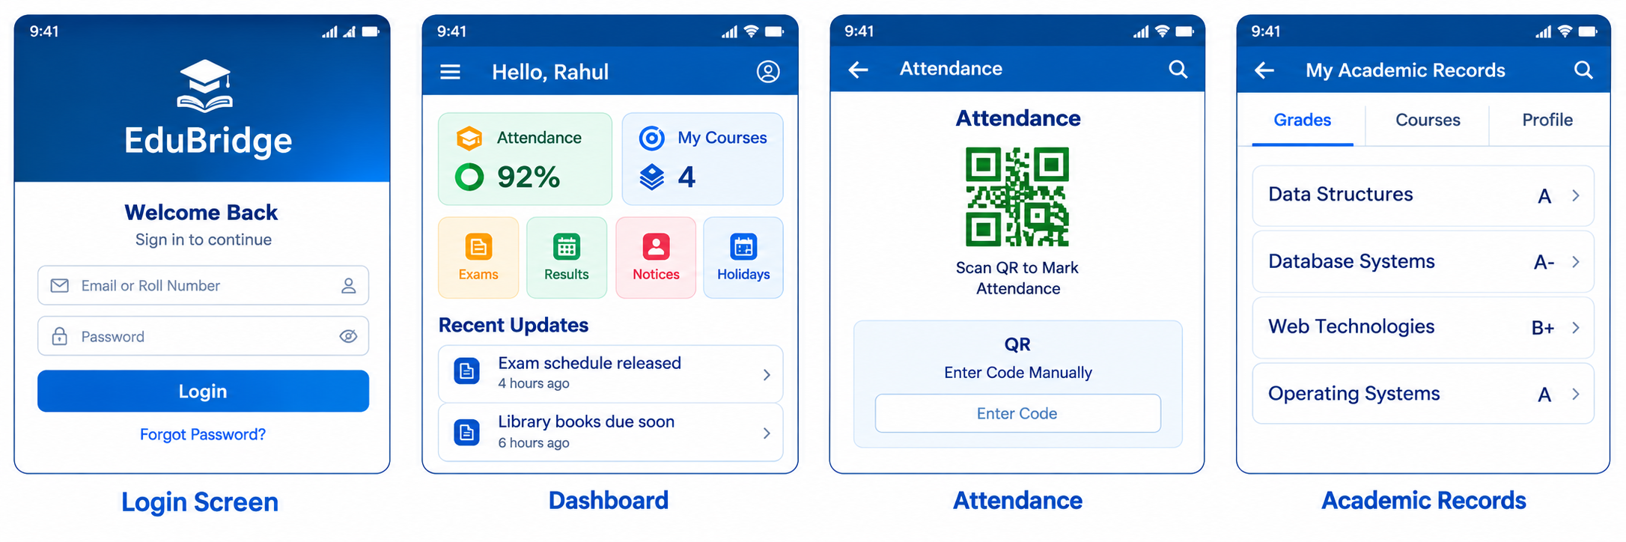

10. DESIGN THINKING – STAGE 4: PROTOTYPE
The prototype is a low-fidelity representation of the proposed workflow. Its purpose is to validate navigation and task understanding before implementation effort is invested.

10.1 Proposed Screens

Screen | Key Elements | Validation Focus
Login | Role-aware authentication and recovery | Can users understand how to enter the system?
Student Home | Attendance, registration, assessments, pending actions | Can the next action be found quickly?
Faculty Worklist | Classes, attendance entry, marks, pending approvals | Can routine tasks be completed efficiently?
Coordinator View | Exceptions, course status, unresolved cases | Can staff identify what needs attention?
Exam Workspace | Schedules, marks validation, result publication | Are sensitive actions clear and controlled?
Request Tracker | Request status, owner, history | Can users understand progress?
Reports | Filters, summary metrics, export action | Can users obtain useful summaries?

10.2 Prototype Navigation
LOGIN → ROLE CHECK → DASHBOARD → SELECT TASK → ENTER/VIEW DATA → CONFIRM → STATUS UPDATE

10.3 Prototype Rules

- Use consistent labels for status values.
- Show only actions allowed for the current role.
- Require confirmation for sensitive changes.
- Keep high-frequency tasks near the main dashboard.
- Display the owner and current status of workflow requests.

11. DESIGN THINKING – STAGE 5: TEST
Testing in Unit–1 is planned as prototype validation rather than production performance testing. The objective is to learn whether users can understand and complete representative tasks.

Test Scenario | Participant | Success Signal
Check registration status | Student | Finds status and next step without assistance.
Record attendance | Faculty | Completes task with minimal navigation.
Review an exception | Coordinator | Identifies unresolved item quickly.
Validate result record | Exam Officer | Understands validation and publication states.
Track an academic request | Student/Staff | Can identify owner and current status.
Generate summary | Coordinator | Can filter and interpret report output.

11.1 Feedback Questions

- What part of the screen was unclear?
- Which information did you expect to see first?
- Did you know what action to take next?
- Did any label or status appear ambiguous?
- Was any notification unnecessary or confusing?

11.2 Iteration Plan

Feedback is recorded as observations, grouped into usability issues, and converted into prototype changes. The updated prototype is tested again. This iterative cycle is consistent with the guide's emphasis on learning before expensive implementation.
Design Thinking summary:
Empathize → understand users; Define → frame the problem; Ideate → generate alternatives; Prototype → make the idea visible; Test → learn and improve.

12. IBM DESIGN THINKING APPLICATION
IBM Design Thinking in this project is applied as a practical product-planning approach. The emphasis is on user outcomes, continuous learning and collaboration among people with different responsibilities.

IBM Principle | Application in EduBridge | Evidence/Measure
Focus on User Outcomes | Measure whether users can complete academic tasks with less uncertainty and fewer unnecessary handoffs. | Task completion, pending-action clarity, user feedback.
Restless Reinvention | Treat prototype decisions and workflow rules as changeable when evidence shows a better approach. | Iteration count, feedback-driven changes.
Diverse Empowered Teams | Bring student, faculty, administrative, examination and IT perspectives into discovery. | Stakeholder participation and review notes.

12.1 Outcome Thinking

A technical output might be described as “build an attendance module.” The corresponding user outcome is “allow a faculty member to record attendance accurately while making the student's current attendance status understandable.” The second statement provides a stronger basis for product validation.

12.2 Restless Reinvention

EduBridge is not treated as a fixed specification. Labels, dashboard priorities, notification rules and workflow steps can change after prototype feedback. The objective is to improve the product based on evidence rather than protect the first design.

12.3 Diverse Empowered Teams

The planning team should include domain users and technical roles. Students and faculty explain real workflows; administrative and examination users explain governance; developers and DevOps contributors identify implementation implications; UX contributors keep the experience understandable.

13. IBM LOOP – OBSERVE → REFLECT → MAKE
The IBM Loop provides a compact way to continue learning after the first prototype or release. In EduBridge, the loop is applied to academic workflows and user behavior.
OBSERVE → REFLECT → MAKE
Stage | EduBridge Activity | Example Learning
Observe | Review prototype sessions, workflow completion, support issues and feedback. | Students repeatedly ask where a pending request is located.
Reflect | Group observations and identify the underlying usability or workflow issue. | The request status is technically available but visually buried.
Make | Change dashboard placement, wording or navigation and test again. | Pending requests become a primary dashboard card.

13.1 Continuous Improvement Cycle
User Interaction → Evidence → Reflection → Design Change → Retest → Updated Experience

13.2 Example Loop

Observe: faculty spend time finding incomplete marks entries. Reflect: the system separates incomplete entries from the daily worklist. Make: add an “Incomplete Records” filter and action count. The revised workflow is then tested with faculty users.

13.3 Why the Loop Matters

The loop keeps product planning connected to real usage. It also provides a bridge between Design Thinking and later DevOps practices, where feedback, monitoring and iterative delivery become continuous engineering activities.

14. FUNCTIONAL REQUIREMENTS SPECIFICATION (FRS)
Functional requirements describe what the proposed platform should do. They are intentionally written so that they can later be transformed into user stories and acceptance criteria.

ID | Functional Requirement
FR-01 | Authenticate users and provide role-based access for student, faculty, coordinator, examination and support roles.
FR-02 | Create and maintain a unified student academic profile.
FR-03 | Allow students to view course registration status and approved subjects.
FR-04 | Allow authorized faculty to record and update attendance.
FR-05 | Calculate and display attendance summaries for authorized users.
FR-06 | Maintain assessment schedules and relevant academic events.
FR-07 | Allow authorized users to enter, validate and publish marks according to workflow.
FR-08 | Allow students to submit defined academic service requests.
FR-09 | Track request status, owner, timestamps and history.
FR-10 | Generate selected academic summaries for authorized staff.
FR-11 | Maintain an audit trail for sensitive updates.
FR-12 | Provide dashboard notifications for selected pending actions.

14.1 Functional Flow
Authenticate → Identify Role → View/Enter Data → Validate → Save → Update Status → Notify/Report

14.2 FRS Validation

Each requirement should later receive acceptance criteria and test cases. Requirements that involve permissions should be tested for both allowed and denied access conditions.
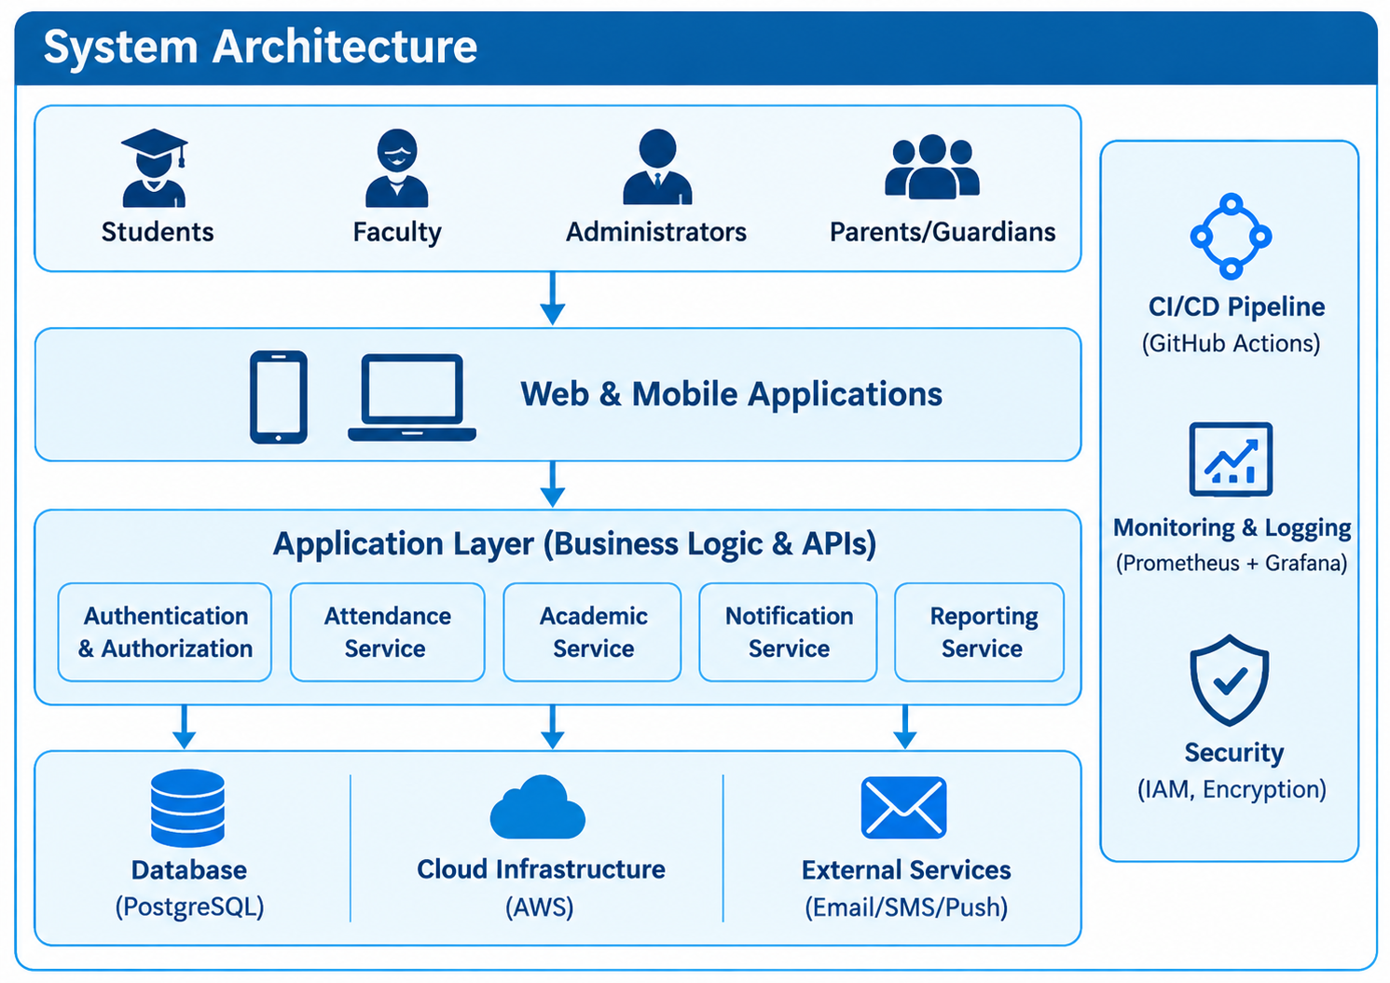

15. NON-FUNCTIONAL REQUIREMENTS SPECIFICATION (NFRS)
Non-functional requirements define the quality characteristics expected from the platform. They are important because a feature-rich academic system is not useful if it is insecure, confusing or unreliable.

ID | Category | Requirement
NFR-01 | Security | Protect academic records through authentication, authorization and secure transport.
NFR-02 | Privacy | Expose student information only to roles with a legitimate operational need.
NFR-03 | Usability | Use consistent navigation and understandable status labels across role dashboards.
NFR-04 | Performance | Common dashboard and record retrieval operations should respond promptly under expected academic usage.
NFR-05 | Reliability | Prevent partial or inconsistent updates during routine transactions.
NFR-06 | Data Integrity | Validate required fields and prevent conflicting duplicate records.
NFR-07 | Maintainability | Separate business modules and keep documentation current.
NFR-08 | Scalability | Allow growth in students, courses, transactions and reports without redesigning the complete product.
NFR-09 | Availability | Keep essential academic workflows available during normal operating periods.
NFR-10 | Auditability | Record important administrative changes with actor and timestamp information.

15.1 Quality Priorities

- Security and access control are essential because academic information is sensitive.
- Usability is essential because the product serves both technical and non-technical users.
- Data integrity is essential because incorrect academic records can affect downstream decisions.
- Maintainability is essential for future Agile and DevOps development.

16. PRODUCT VISION AND SUCCESS MEASURES

16.1 Vision Statement

To provide a clear and dependable digital workspace through which students and academic teams can manage everyday academic activities, understand current status and complete required actions with fewer manual handoffs.

16.2 Mission Statement

Understand academic workflows, simplify high-frequency tasks, make ownership visible, validate the experience through iterative Design Thinking, and prepare a maintainable product foundation for Agile and DevOps delivery.

16.3 Product Objectives

- Create a consistent academic profile across core workflows.
- Make registration and request status visible to the relevant user.
- Reduce unnecessary manual compilation for routine academic summaries.
- Provide role-specific dashboards rather than one overloaded interface.
- Establish traceability for sensitive academic changes.
- Create a foundation that can evolve through later development units.

16.4 Success Criteria

Measure | What It Indicates
Task completion rate | Whether users can complete key workflows.
Time to locate status | Whether information is easy to find.
Pending-action clarity | Whether users know what to do next.
Error/rework frequency | Whether workflows reduce avoidable mistakes.
User feedback | Whether the experience meets stakeholder expectations.
Requirement coverage | Whether the MVP delivers the planned product promise.

17. MINIMUM VIABLE PRODUCT (MVP)
The MVP is the smallest release that can test the central product idea: a shared academic workspace that makes current status and required actions clear.

MVP Feature | Description | Priority
Secure Login & Roles | Role-specific entry and access control. | Core
Student Profile | Academic identity and basic program information. | Core
Course Registration | View, submit and track registration status. | Core
Attendance Summary | Authorized entry plus student-facing summary. | Core
Assessment Calendar | Upcoming assessment information in one place. | Core
Marks Workflow | Authorized entry, validation and publication states. | Core
Academic Requests | Submit and track selected service requests. | Core
Action Notifications | Selected reminders for pending tasks. | Core
Basic Reports | Role-appropriate academic summaries. | Core
Audit Trail | Record sensitive changes and actors. | Core

17.1 Deferred Features

- Advanced predictive analytics
- Conversational academic assistant
- Large-scale external messaging integrations
- Complex recommendation engines
- Full institutional ERP replacement

17.2 MVP Principle

The MVP should validate the workflow experience before the product expands into advanced intelligence or broad integration. Deferred features remain possible future directions rather than commitments for the first release.

18. PRODUCT ROADMAP
Phase | Focus | Main Output
Phase 1 | Domain Discovery | Workflow map, stakeholders, personas and problem definition.
Phase 2 | Design Thinking | Ideas, low-fidelity prototype and test plan.
Phase 3 | Requirements & Agile Planning | Prioritized backlog, FRS, NFRS and acceptance criteria.
Phase 4 | Core Platform | Authentication, profiles, registration and basic academic records.
Phase 5 | Workflow Modules | Attendance, assessments, marks and academic requests.
Phase 6 | Quality & DevOps | Testing, containerization, CI/CD and environment automation.
Phase 7 | Deployment & Improvement | Operational rollout, monitoring and feedback-driven refinement.

19. INITIAL SYSTEM ARCHITECTURE
The architecture is conceptual at Unit–1 stage. It identifies responsibilities without locking the project into a final technology stack.
Users → Web/Mobile Interface → Application/API Layer → Business Modules → Database

19.1 Supporting Components

- Authentication and authorization service for role enforcement.
- Workflow modules for registration, attendance, assessment, requests and results.
- Notification component for selected reminders.
- Audit component for sensitive changes.
- Reporting layer for authorized summaries.
- DevOps layer for automated build, test, deployment and monitoring in later units.

19.2 Architecture Principles

- Keep business modules logically separated.
- Protect data at every access layer.
- Prefer reusable services over duplicated logic.
- Design interfaces so the frontend can evolve independently from core business rules.
- Introduce infrastructure automation after requirements stabilize.

20. PROJECT CHARTER AND MILESTONES
Charter Element | Definition
Project Title | EduBridge – Academic Operations & Student Success Platform
Purpose | Plan a role-based academic workflow product before implementation.
Primary Users | Students, faculty, coordinators, examination staff and IT support.
Scope | Business understanding, Design Thinking, requirements, MVP, roadmap and architecture.
MVP | Profiles, registration, attendance, assessment calendar, marks workflow, requests, notifications and basic reports.
Major Deliverables | BRD, personas, stakeholder analysis, FRS, NFRS, Design Thinking report, IBM documentation, MVP, roadmap, architecture and repository plan.
Constraint | Unit–1 focuses on product discovery and planning rather than full implementation.
Success | A coherent product plan ready for Agile development.

20.1 Milestone Plan

- Business understanding and problem definition
- Stakeholder mapping and persona development
- Design Thinking documentation
- IBM Design Thinking and Loop documentation
- Functional and non-functional requirements
- Product vision and MVP definition
- Roadmap and architecture concept
- Project charter and repository structure
- Final product discovery review

21. REPOSITORY INITIALIZATION AND FOLDER STRUCTURE
edubridge-platform/
├── .github/ # CI/CD workflows
├── app/
│ ├── auth/ # authentication and roles
│ ├── students/ # student profiles
│ ├── registration/ # course registration
│ ├── attendance/ # attendance services
│ ├── assessments/ # schedules and marks
│ ├── requests/ # academic requests
│ └── reports/ # reporting services
├── tests/ # unit and integration tests
├── docs/ # BRD, FRS, NFRS and design records
├── deployment/ # deployment manifests
├── monitoring/ # monitoring configuration
└── README.md # setup and project overview

22. PRODUCT DISCOVERY DOCUMENTATION
Discovery Area | Decision / Finding
Target Domain | Higher-education academic operations and student services.
Primary User Groups | Students and faculty, with coordinators, exam staff and IT as key operational stakeholders.
Core Problem | Disconnected workflows make status, ownership and next actions difficult to track.
Core Solution | Role-based academic workspace with workflow visibility and controlled records.
Design Approach | Design Thinking plus IBM Design Thinking and Observe → Reflect → Make.
MVP Decision | Prove core academic workflows before advanced analytics or AI features.
Future Direction | Expand reporting, integrations and intelligent assistance after validated usage.

23. CONCLUSION AND FUTURE DIRECTION
EduBridge has been planned as a complete academic operations product rather than a collection of screens. The project focuses on understanding the needs of students, faculty and administrators, applying the Design Thinking approach, and converting the findings into clear requirements, product vision, MVP, roadmap and conceptual architecture. This approach provides a structured understanding of how the proposed system can address common academic management challenges.
The Unit–1 outcome provides a strong foundation for future Agile and DevOps development. In the next stage, the identified requirements can be converted into user stories and prioritized for iterative MVP development. The system can then be developed, tested and improved through regular feedback from students, faculty and administrators. DevOps practices can further support automated testing, continuous integration, deployment and system monitoring.
Future enhancements may include academic analytics, automated notifications, mobile support, improved security, performance monitoring and AI-based academic insights. Features such as personalized student dashboards, attendance alerts and academic performance analysis can further improve the usefulness of the platform. The Observe → Reflect → Make cycle can be continued throughout development to ensure that EduBridge remains user-centered, scalable and adaptable to changing institutional needs.

